Test Plan
Document
for
OpenCart

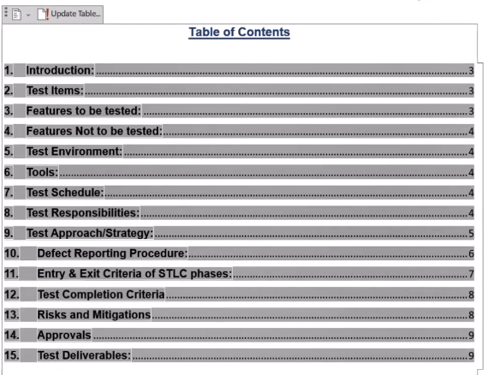

- INTRODUCTION:
This test plan is for the E-Commerce Application OpenCart, version 1.0. The objective of this testing is to ensure that the application meets the requirements and is free of defects. This document serves as high level test planning. document with details on the scope of the project, test strategy, test schedule, resource requirements and test deliverables.

- TEST ITEMS:
E-Commerce Application: OpenCart, version X.X

- FEATURES TO BE TESTED:

• Register
• Login & Logout
• Forgot Password
• Search
• Product Compare
• Product Display Page
• Add to Cart
• Wish List
• Shopping Cart
• Currencies
• Home Page
• Checkout Page
• My Account Page
• Order History Page
• Downloads Page
• Contact Us Page
• Menu Options
• Footer Options
• Category Pages
As per our understanding, we believe above functional areas need to be Tested.
- FEATURES NOT TO BE TESTED:
• Features not mention in the section 3,"Feature to be tested" will not be tested.
• Payment Gateway will be tested.
• Automation testing is not in scope.

- TEST ENVIRONMENT:
• Operating System: Windows 10
• Browser: Google Chrome, Firefox, Edge
• Operating System: MAC O.S ….. (Multiple environment )
• Browser: Google Chrome, Firefox, Edge
- TOOLS:
• Bug Tracking Tool
• Word and Excel documents

- TEST SCHEDULE:
• Test Planning: Start Date (dd/mm/yy)- End Date (dd/mm/yy)
• Test Case Development: Start Date (dd/mm/yy)- End Date (dd/mm/yy)
• Test Execution: Start Date (dd/mm/yy)- End Date (dd/mm/yy)
• Test Closure: Date

- TEST RESPONSIBILITIES:
Name | Role | Responsibilities
Mr. | Test Manager | Escalate issues
Ms.... | Test Lead | * Create the Test Plan and get the client signoffs
 |  | * Interact with the application, create and execute the test cases
 |  | * Report defects
 |  | * Coordinate the test execution. Verify validity of the defects being reported.
 |  | * Submit daily issue updates and summary defect reports to the client.
 |  | * Attend any meeting with client.
 | Senior Test Engineer | * Interact with the application
 |  | * Create and Execute the Test cases
 |  | * Report defects
 | Test Engineer | * Interact with the application
 |  | * Execute the Test cases
 |  | * Report defects
 | Developer | * Bug fixing and providing support during testing
 | Server Admin | * Responsible for maintaining the test environment

- Test Approach/Strategy:
Manual testing will be used to test all the features/functionalities of the OpenCart application. As a part of functional testing, following approach will be followed.

Step#1 - Creation of Test Scenarios and Test Cases for the different features in scope (Refer section 3. Features to be tested).
• We will apply several Test Designing techniques while creating Test Cases
➤ Equivalence Class Partition
➤ Boundary Value Analysis
➤ Decision Table Testing
➤ State Transition Testing
➤ Use Case Testing
We also use our expertise in creating Test Cases by applying the below:
➤ Error Guessing
➤ Exploratory Testing

• We prioritize the Test Cases

Step#2 - Our Testing process, when we get an Application for Testing:
• Firstly, we will perform Smoke Testing to check whether the different and important functionalities of the application are working.
• We reject the build, if the Smoke Testing fails and will wait for the stable build before performing in depth testing of the application functionalities.
• Once we receive a stable build, which passes Smoke Testing, we perform in depth testing using the Test Cases created.
• Multiple Test Resources will be testing the same Application on Multiple Supported Environments simultaneously.
• We then report the bugs in bug tracking tool and send dev. management the defect found on that day in a status end of the day email.
• As part of the Testing, we will perform the below types of Testing:
➤ Smoke Testing and Sanity Testing
➤ Regression Testing and Retesting
➤ Usability Testing, Functionality & UI Testing
• We repeat Test Cycles until we get the quality product.

Step#3 - We will follow the below best practices to make our Testing better:

• Context Driven Testing We will be performing Testing as per the context of the given application.
• Shift Left Testing - We will start testing from the beginning stages of the development itself, instead of waiting for the stable build.
• Exploratory Testing - Using our expertise we will perform Exploratory Testing, apart from the normal execution of the Test cases.
10. Defect Reporting Procedure:

During the test execution –
• Any deviation from expected behavior/result by the application will be noted. If it can't be reported as a defect, it would be reported as an observation/issue or posed as a question.
• Any usability issues will also be reported.
• After discovery of a defect, it will be retested to verify reproducibility of the defect.
• Screenshots with steps to reproduce defect are to be documented. • Every day, at the end of the test execution, defects encountered will be sent along with the observations.

Note:
• Defects will be documented in a excel
• Test scenarios and Test cases will be documented in an excel document.

- Entry & Exit Criteria of STLC phases:

STLC Phase | Entry Criteria | Exit Criteria
Requirement Analysis | Once the testing team receives the Requirements Documents or details about the Project. | List of Requirements are explored and understood by the Testing team. * All Doubts are cleared.
Test Planning | Testable Requirements derived from the given Requirements Documents or Project details. Doubts are cleared. | Test plan document signed off by the client.
Test Design | Test plan document signed off by the client. | Test Scenarios and Test Cases Documents are signed-off by the Client.
Test Execution | Test Scenarios and Test Cases Documents are signed-off by the Client.  Application is ready for Testing. | Test Case Report and Defect Report are ready.
Test Closure | Test Case Reports, Defect Reports are ready. | Test Closure Report.

- Test Completion Criteria:
• All the identified defects must be fixed and verified.
• All the test cases must be executed and passed.
• All the test deliverables must be completed and submitted.
• Performance test should pass the threshold limit.

- Risks and Mitigations:
1. Risk: Non-Availability of a Resource
Mitigation: Plan for backup resource
2. Risk: Build URL is not working
Mitigation: Resources will work on other tasks

14. Approvals:
Following documents needs client's approval.
• Test Plan
• Test Scenarios
• Test Cases
• Reports
Testing will only continue to the next steps once these approvals are done.
- Test Deliverables:
• Test cases
• Test reports
• Defect reports

